Experiment 16: digital tube display experiment
Digital tube is a common display digital display, daily life, for example: electromagnetic oven, full automatic washing machine, solar water temperature display, electronic clock... And so on the number of not very few. To control the display of digital control principle, it is necessary to.
The cathode of field digital tube, digital tube display digital tube is a kind of semiconductor light emitting devices, the basic unit is the light-emitting diode, digital tube according to the number of segments is divided into seven segment digital tube and eight digital tube, eight digital tube than seven segment digital tube more than a light emitting diode unit (more than one decimal point), the use of eight digital tube. According to the light emitting diode unit connection mode is divided into common anode and cathode nixie tube. Yang digital tube is refers to all the light emitting diode anode received together form a common anode (COM) digital tube anode in the application should be public com received + 5V, when a light emitting diode for low electricity at ordinary times When a field of cathode for high electric power, the corresponding field is not bright. Common cathode digital tube is all led to form a common cathode (COM) digital tube. Common cathode digital tube in the application should be COM to the ground GND, when a field light-emitting diode anode for high power, the corresponding field is lit. When a field of anode for low power, the corresponding field is not bright.
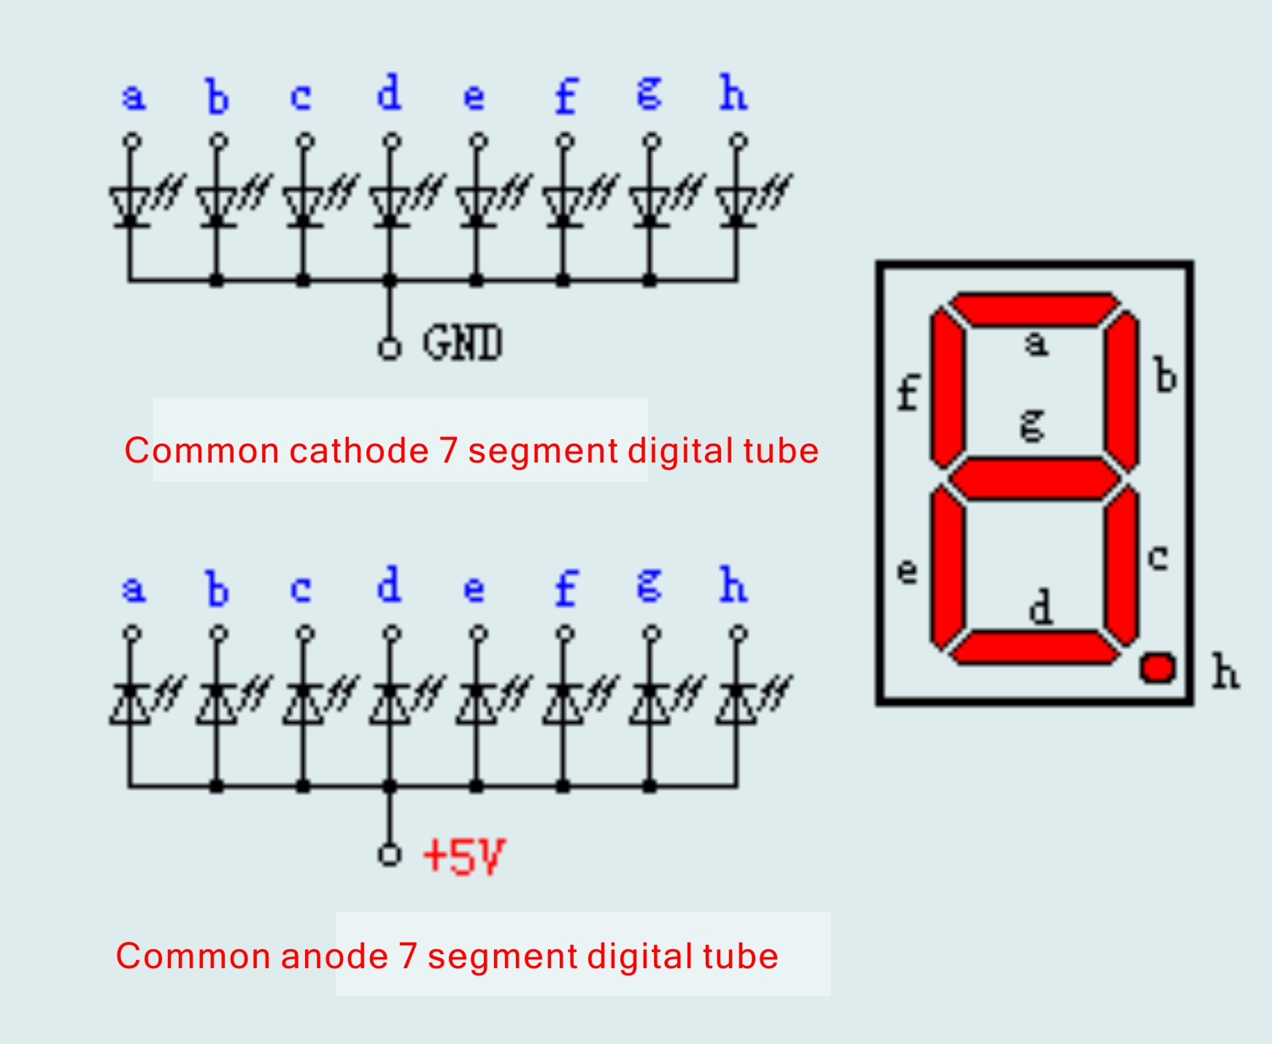
Each of the digital tube is composed of light-emitting diodes, so when using the same as the light-emitting diode, but also to connect the current limit resistance, otherwise the current will burn the light emitting diode. This experiment with a common cathode digital tube, common cathode digital tube in the application should be GND, when a field light-emitting diode anode for low power, the corresponding field points out,
We begin to prepare the experimental components。
Eight segment digital tube *1

220 ohm line resistance *8

Bread board *1 bread board jumper *1 tie

We refer to the physical connection diagram to connect the circuit according to the schematic diagram.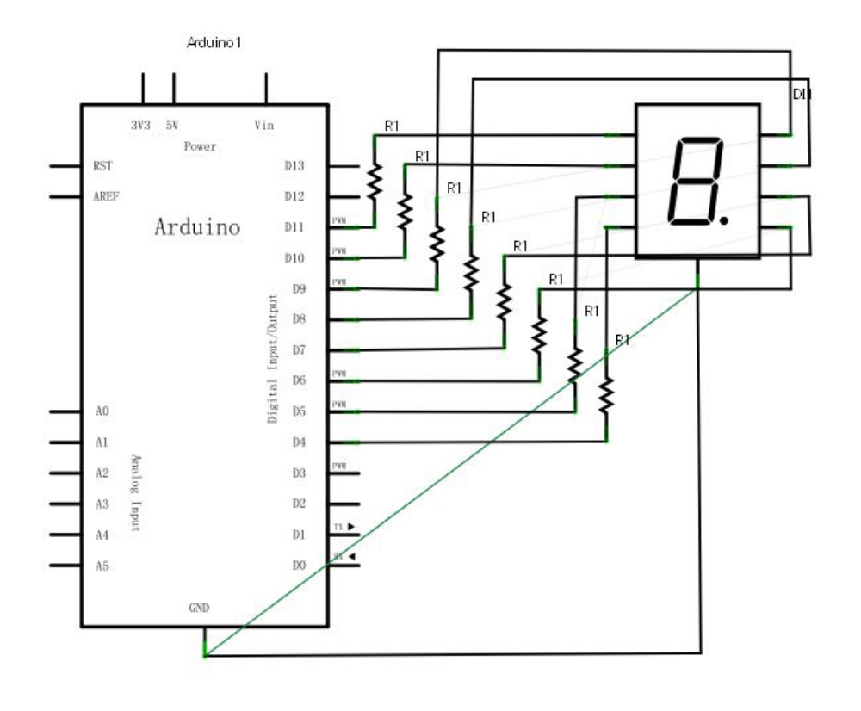
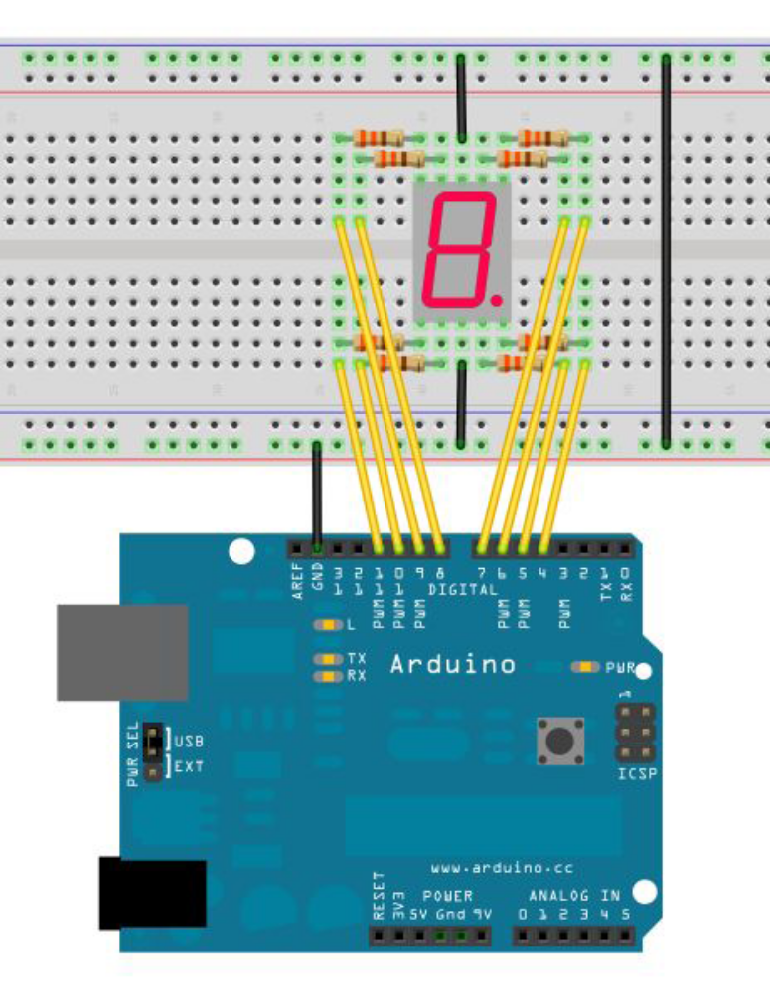
Digital control of a total of seven sections show the number of segments, there is a display of the decimal point. When the digital tube display digital, as long as the corresponding period of light can be. For example: the digital tube display digital 1, C, B section will be lit. In the main program every 2S display a number, 1 to 8 digital display.
Reference source code:
//Set pin control all digital IO
int a=7;//Definition of digital interface 7 connected a segment digital tube
int b=6;// Definition of digital interface 6 connected B segment digital tubeint c=5;// Definition of digital interface 5 connected C segment digital tube
int d=10;// Definition of digital interface 10 connected D segment digital tube
int e=11;// Definition of digital interface 11 connected e segment digital tube
int f=8;// Definition of digital interface 8 connected f segment digital tube
int g=9;// Definition of digital interface 9 connected g segment digital tube
int dp=4;// Definition of digital interface 4 connected DP segment digital tube
void digital_0(void) //Display number 5
{
unsigned char j;
digitalWrite(a,HIGH);
digitalWrite(b,HIGH);
digitalWrite(c,HIGH);
digitalWrite(d,HIGH);
digitalWrite(e,HIGH);
digitalWrite(f,HIGH);
digitalWrite(g,LOW);
digitalWrite(dp,LOW);
}
void digital_1(void) //Display number 1
{
unsigned char j;
digitalWrite(c,HIGH);//Digital interface to the 5 pin high, lit C segment
digitalWrite(b,HIGH);//Light B segment
for(j=7;j<=11;j++)//Extinguish the rest
digitalWrite(j,LOW);
digitalWrite(dp,LOW);//Put out the DP segment of the decimal point
}
void digital_2(void) //Display number 2
{
unsigned char j;
digitalWrite(b,HIGH);
digitalWrite(a,HIGH);
for(j=9;j<=11;j++)
digitalWrite(j,HIGH);
digitalWrite(dp,LOW);
digitalWrite(c,LOW);
digitalWrite(f,LOW);
}
void digital_3(void) //Display number3
{
digitalWrite(g,HIGH);
digitalWrite(a,HIGH);
digitalWrite(b,HIGH);
digitalWrite(c,HIGH);
digitalWrite(d,HIGH);
digitalWrite(dp,LOW);
digitalWrite(f,LOW);
digitalWrite(e,LOW);
}
void digital_4(void) //Display number 4
{
digitalWrite(c,HIGH);
digitalWrite(b,HIGH);
digitalWrite(f,HIGH);
digitalWrite(g,HIGH);
digitalWrite(dp,LOW);
digitalWrite(a,LOW);
digitalWrite(e,LOW);
digitalWrite(d,LOW);
}
void digital_5(void) //Display number 5
{
unsigned char j;
digitalWrite(a,HIGH);
digitalWrite(b, LOW);
digitalWrite(c,HIGH);
digitalWrite(d,HIGH);
digitalWrite(e, LOW);
digitalWrite(f,HIGH);
digitalWrite(g,HIGH);
digitalWrite(dp,LOW);
}
void digital_6(void) //Display number 6
{
unsigned char j;
for(j=7;j<=11;j++)
digitalWrite(j,HIGH);
digitalWrite(c,HIGH);
digitalWrite(dp,LOW);
digitalWrite(b,LOW);
}
void digital_7(void) //Display number7
{
unsigned char j;
for(j=5;j<=7;j++)
digitalWrite(j,HIGH);
digitalWrite(dp,LOW);
for(j=8;j<=11;j++)
digitalWrite(j,LOW);
}
void digital_8(void) //Display number 8
{
unsigned char j;
for(j=5;j<=11;j++)
digitalWrite(j,HIGH);
digitalWrite(dp,LOW);
}
void digital_9(void) //Display number 5
{
unsigned char j;
digitalWrite(a,HIGH);
digitalWrite(b,HIGH);
digitalWrite(c,HIGH);
digitalWrite(d,HIGH);
digitalWrite(e, LOW);
digitalWrite(f,HIGH);
digitalWrite(g,HIGH);
digitalWrite(dp,LOW);
}
void setup()
{
int i;//defined variable
for(i=4;i<=11;i++)
pinMode(i,OUTPUT);//Set the 11 to 4 pin for the output mode
}
void loop()
{
while(1)
{
digital_0();//Display number 1
delay(1000);//delay 1s
digital_1();//Display number 1
delay(1000);//delay 1s
digital_2();//Display number2
delay(1000); //delay 1s
digital_3();//Display number3
delay(1000); //delay 1s
digital_4();//Display number 4
delay(1000); //delay 1s
digital_5();//Display number 5
delay(1000); //delay 1s
digital_6();//Display number 6
delay(1000); //delay 1s
digital_7();//Display number7
delay(1000); //delay 1s
digital_8();//Display number 8
delay(1000); //delay 1s
digital_9();//Display number 9
delay(1000); //delay 1s
}
}

Experimental phenomenon: digital tube display 0-9 cycle display.

